# GREEN CART

SUBMITTED BY

Group Number - 5

Ishita Ghosh, 200020275986, 2012200002027

Soumyajit Nag, 200020216959, 2011200002021

Srijan Singh, 200020233596, 2011200002023

Anirudh Jalan, 200020022811, 2011200002002

Under the Supervision of

Professor Soma Hazra

Assistant Professor



# Content Page No

1. **Introduction 2**
2. **Methodology 2-3**
   1. **Problem Specification 2-3**
   2. **Significance of the proposed problem 3**
3. **Literature Review 3-4**
4. **Detailed Methodology 4-5**
5. **Conclusions and Future Plan 5-6**

**Acknowledgement 6-7**

**References 7**

# INTRODUCTION:

Our e-commerce platform responds to the increasing demand for sustainable living by exclusively offering eco-friendly products. Unlike traditional platforms, we focus on environmental impact, providing a dedicated marketplace for environmentally conscious goods.

Driven by the urgency of environmental concerns and changing consumer preferences, our project contributes to fostering an environmentally responsible and ethically conscious consumer culture.

In the industrial landscape, our platform addresses the rising demand for eco-friendly products in the business-to-business (B2B) sector as corporations adopt sustainable practices. This underscores the relevance and viability of our project in the contemporary market.

# **METHODOLOGY:**

## PROBLEM SPECIFICATION

Ensure teams have clear, achievable goals aligned with company objectives, employing SMART criteria. Foster open communication using collaboration tools such as Slack or project management software. Conduct regular meetings and check-ins to discuss progress, challenges, and strategies. Prioritize continuous learning and skill development through training programs to keep the team updated on e-commerce trends and technologies.

Currently, the team is collaboratively working on the project homepage and login page designing so that we can achieve our future targets of incorporating new features with upcoming time, for eg, cart operation, getting more products, recommendation system, voice/picture input for the product, making the backend, database and connecting them together to make in totally working fine and conducting rigorous testing and improvising the product and few other features as well.

## WHY IS THIS PROBLEM SIGNIFICANT / NEED FOR THE STUDY

The significance of addressing the need for an e-commerce platform dedicated to sustainable products in India is underscored by the limited presence of brands in this space (eg - Brown Living, Sustain Kart, Ecohoy, etc ). The scarcity of such offerings presents an opportunity to fill a crucial gap in the market. By establishing a platform exclusively focused on sustainable products, we aim to meet the rising consumer demand for eco-friendly options. This not only caters to the evolving preferences of environmentally conscious consumers but also contributes to the larger goal of promoting sustainable living practices in the Indian market.

# LITERATURE REVIEW / RELATED RESEARCH OUTCOMES

* Sustainable E-commerce Practices

*Author*: Smith, J.

*Year*: 2020

*Source*: Journal of Sustainable Business

*Key Findings*: Smith conducted a comprehensive study on sustainable e-commerce practices, emphasizing the importance of eco-friendly packaging, supply chain transparency, and consumer awareness. The study highlights the positive impact of incorporating sustainable practices on customer loyalty and brand reputation.

Limitations: Potential lack of universal applicability and vulnerability to rapid technological and consumer preference changes.

* Environmental Impact of E-commerce

*Author*: Green, A.

*Year*: 2019

*Source*: Sustainability Today

*Key* *Findings*: Green's research delves into the environmental impact of e-commerce, focusing on carbon footprints, waste generation, and energy consumption. The study offers insights into mitigating these impacts through innovative logistics, green technology, and sustainable packaging.

*Limitations*: Variability in data reliability and potential oversight of external factors like governmental policies influencing environmental impact.

* Consumer Behavior and Sustainable E-commerce

*Author*: Johnson, M.

*Year*: 2021

*Source*: International Journal of Consumer Studies

*Key Findings*: Johnson's study explores consumer behavior in the context of sustainable e-commerce. It investigates factors influencing purchase decisions, the role of ethical marketing, and the effectiveness of eco-labels. Understanding these aspects is crucial for tailoring marketing strategies.

*Limitations*: Susceptibility to self-reporting bias and limited universality due to cultural differences in consumer choices.

* Sustainable Supply Chains in E-commerce

*Author*: Brown, L.

*Year*: 2018

*Source*: Supply Chain Management Review

*Key Findings*: Brown's research focuses on the integration of sustainable practices in e-commerce supply chains. The study identifies challenges and opportunities, emphasizing the need for collaboration among stakeholders to achieve a more sustainable and ethical supply chain.

*Limitations*: Industry-specific strategies and potential resistance from supply chain stakeholders may restrict generalizability.

* Technology Solutions for Sustainable E-commerce

*Author*: Chen, Y

*Year*: 2022

*Source*: Proceedings of the International Conference on Sustainable Technologies

*Key Findings*: Chen explores technological solutions for enhancing the sustainability of e-commerce platforms. The study discusses the role of blockchain, AI, and data analytics in improving supply chain transparency, reducing waste, and optimizing resource use.

*Limitations*: Challenges in technology adoption, including cost concerns, lack of expertise, and potential biases towards specific technologies.

# DETAIL METHODOLOGY

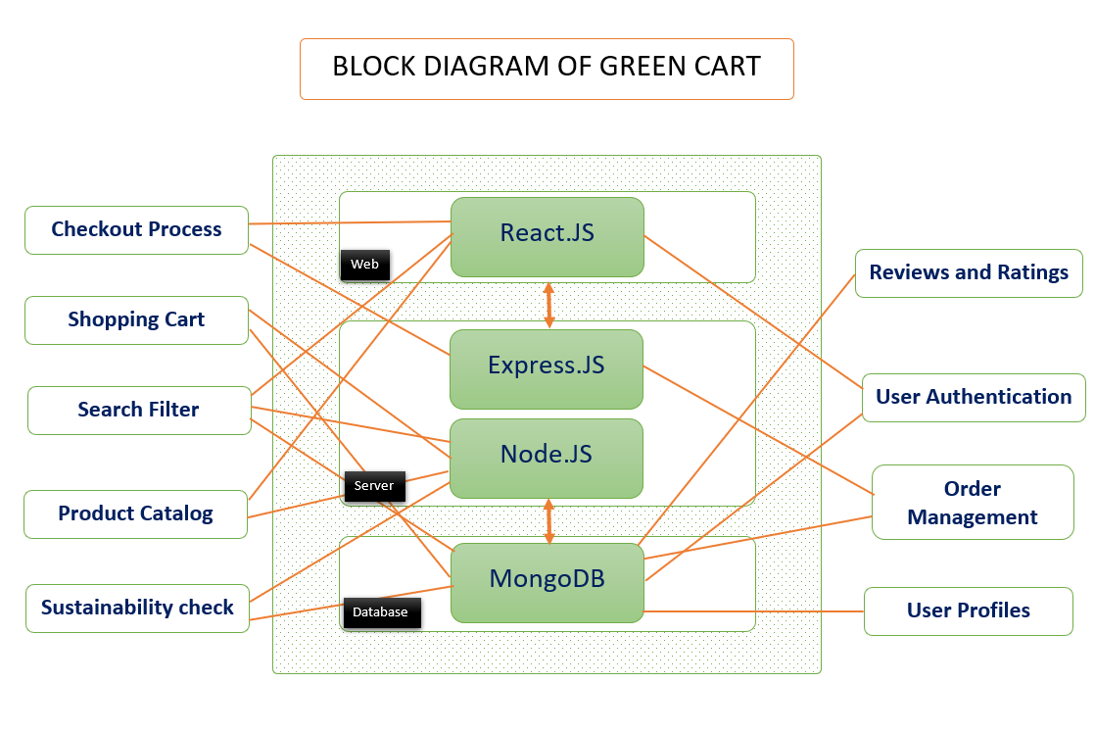

# 

# *User Authentication*:

# Developed a secure user authentication system using MongoDB for storing user profiles and Express for server-side logic.

# *Product Catalog*:

# Implemented a product catalog using MongoDB as the database to store product information, and Express to handle API requests for product retrieval.

# *Shopping Cart*:

# Integrated a shopping cart functionality to allow users to add, modify, and remove items before proceeding to checkout.

# *Checkout Process*:

# Created a smooth and secure checkout process using React for the front end, Express for server-side processing, and integrated payment gateways for transactions.

# *Order Management:*

# Developed an order management system to track and manage customer orders, utilizing MongoDB for storing order details and Express for order processing logic.

# *User Profiles*:

# Implemented user profiles where customers can view order history, manage personal information, and track their purchases.

# *Search and Filter*:

# Included a robust search and filter system to help users easily find sustainable products based on categories, prices, and other relevant criteria.

# *Reviews and Ratings*:

# Integrated a review and rating system, allowing users to provide feedback on products and helping build trust among potential customers.

# CONCLUSIONS and FUTURE PLAN

In concluding our project, our team's collective effort and dedication have led to a significant achievement. Through meticulous planning, execution, and collaboration, we tried to build an ecommerce website . One notable outcome is sustainable - eco friendly products marketplace, validating our objectives and showcasing our team's capability to overcome challenges.

Throughout the project, we navigated various challenges, turning them into opportunities for growth and innovation. Lessons learned strengthened our problem-solving skills and contributed to the overall resilience of our team.

Importantly, the project has worked on creating a platform for sustainable products. The positive influence extends beyond its immediate scope.

Collaboration has been a cornerstone of our success. Diverse skills and perspectives enriched our approach, fostering creativity and mutual support. Seamless coordination and communication were pivotal in achieving our goals.

Reflecting on the journey, this experience has deepened our understanding of developing an e-commerce sustainable product marketplace and equipped us with transferable skills for future endeavors.

In closing, we express gratitude to all who contributed to this project — team members, mentors, and stakeholders. The impact of our collective effort will resonate beyond this project, leaving a lasting mark on our professional journeys.

Thank you for being part of this transformative experience.

Sincerely,

Group 5 (GREENCART)

In the next few months, we will do the following tasks:-

* AI-recommendation system and chat-bot.
* Customer verification.
* Operational Cart System.
* Review system.
* Sustainable percentage show.
* Credit System.

**ACKNOWLEDGEMENT:**

We extend our heartfelt gratitude to our esteemed project mentor for their invaluable guidance, unwavering support, and insightful direction throughout the development of our project. Their mentorship has been instrumental in shaping our ideas, refining our approach, and ultimately steering us towards the successful completion of this endeavor.

Our mentor's expertise, patience, and commitment to excellence have been a constant source of inspiration. Their ability to provide constructive feedback, share profound industry knowledge, and encourage us to explore innovative solutions has been pivotal in our growth as individuals and as a project team.

We are profoundly thankful for the time and effort our mentor dedicated to understanding our goals, navigating challenges, and fostering an environment of collaborative learning. Their mentorship has not only enhanced the quality of our project but has also left a lasting impact on our personal and professional development.

In recognition of their outstanding mentorship, we express our sincere appreciation to Professor Soma Hazra for being a guiding light on our journey. Your support has been invaluable, and we are grateful for the opportunity to learn and grow under your mentorship.

With deep appreciation,

Group 5 (GREENCART)

# REFERENCES**:**

# <https://sustainkart.com/>

# <https://earthhero.com/>

# <https://brownliving.in/>

# <https://www.loopify.world>

# <https://packagefreeshop.com/>

# <https://www.mongodb.com/>

# <https://blog.hubspot.com/>

# [**https://acowebs.com/**](https://acowebs.com/)

# <https://www.thegoodtrade.com/category/home/zero-waste/>

# 